
TRIBHUVAN UNIVERSITY
Faculty of Humanities and Social Science

A PROJECT REPORT ON
“Railway Reservation System”

Submitted to
Department of Computer Application
Padma Kanya Multiple Campus

In partial fulfillment of the requirements for the Bachelors in Computer Application

Submitted By
Nirmala Chapagain
BCA 6th Semester
Registration No: 6-2-38-192-2021
August 2025

Under the supervision of
Ramesh Signh Saud

Tribhuvan University
Faculty of Humanities and Social Sciences
Padma Kanya Multiple Campus

SUPERVISOR’S RECOMMENDATION

I hereby recommend that this project be prepared under my supervision by Nirmala Chapagain entitled “Railway Reservation System” in partial fulfillment of the requirements for the degree of Bachelor in Computer Application is recommended for final evaluation.

………………….
Mr. Ramesh Signh Saud
Project Supervisor
BCA Department
Padma Kanya Multiple Campus
Bagbazaar, Kathmandu

Tribhuvan University
Faculty of Humanities and Social Sciences
Padma Kanya Multiple Campus

LETTER OF APPROVAL

This is to certify that this project be prepared under my supervision by Nirmala Chapagain entitled “Railway Reservation System” in partial fulfillment of the requirements for the degree of Bachelor in Computer Application is recommended for the final evaluation. In our opinion it is satisfactory in the scope and quality as a project for the required degree.

…………………………. ….…………………
Mr. Ramesh Signh Saud Mr. Kumar Prasun
Supervisor /Lecturer Head of Department
Department of Computer Application Department of Computer Application
Padma Kanya Multiple Campus Padma Kanya Multiple Campus
Bagbazar, Kathmandu Bagbazar, Kathmandu

……………………… …………………….
Internal Examiner External Examiner

ACKNOWLEDGEMENT
I would like to express our special thanks of gratitude to our supervisor Mr. Ramesh Signh Saud who gave me the golden opportunity to do this wonderful project on the topic of “Railway Reservation System” which also helped me in doing a lot of research and I came to know about so many new tools and technologies.
I would like to express our special gratitude and thanks to our BCA Program Coordinator Kumar Prasun for his support and help for our personnel development and mainly for the completion of this Project.
I am highly indebted to Padma Kanya Multiple Campus for their guidance and constant supervision as well as for providing necessary information regarding the Project and support in the completion.
I would also like to express my gratitude towards library and member of Padma Kanya Multiple Campus for their kind co-operation and encouragement which help me in completion of this Project.
I would also like to thank our parents and friends who helped me a lot in finalizing this project within the limited time frame.
In the end, I would also like to thank Tribhuvan University for giving me this opportunity via the course of Computer Application to help me understand the project ethics at this early stage and helped me to evaluate my knowledge and expand it a little more.

Yours sincerely,
Nirmala Chapagain

ABSTRACT
The Railway Reservation System is a web-based application designed to automate the process of booking train tickets and managing related operations such as train schedules, seat availability, user registrations, and payment handling. This system aims to provide a user-friendly and efficient platform for passengers, administrators, and railway staff to perform and manage ticket reservations, cancellations, and inquiries in real-time.
The core objective of this system is to streamline the manual railway booking process by enabling digital interactions between users and the railway database. Registered users can log in to the platform to search for available trains, select travel classes, view seat availability, and book tickets according to their travel plans. Additional features such as meal preferences, coupon codes, and travel history are also supported. The system ensures secure user authentication, and all bookings are processed with real-time updates.
For administrators, the system offers a dedicated dashboard to manage trains, schedules, seat allocations, booking records, and user queries. It enhances operational efficiency by reducing the dependency on manual processing and minimizing the chances of errors or overbooking.
Although the system is designed to be highly functional, it may have some limitations such as dependency on internet connectivity, restricted access for guest users, and limited offline support. Nevertheless, the Railway Reservation System significantly improves the overall ticket booking experience, ensures better data accuracy, and provides a scalable foundation for further enhancements in railway services.

TABLE OF CONTENTS
SUPERVISOR’S RECOMMENDATION i
LETTER OF APPROVAL ii
ACKNOWLEDGEMENT iii
ABSTRACT iv
TABLE OF CONTENTS v
LIST OF ABBREVIATIONS viii
LIST OF FIGURES ix
LIST OF TABLES x
CHAPTER 1: INTRODUCTION 1
1.1 Introduction 1
1.2 Problem Statement 1
1.3 Objective 2
1.4 Scope and Limitations 2
1.5 Development Methodology 2
1.6 Report Organization 3
CHAPTER 2: BACKGROUND STUDY AND LITERATURE REVIEW 5
2.1 Background Study 5
2.2 Literature Review 5
CHAPTER 3: SYSTEM ANALYSIS AND DESIGN 7
3.1 System Analysis 7
3.1.1 Requirement Analysis 7
i. Functional Requirement 7
ii. Non-Functional Requirement 8
3.1.2 Feasibility Study 8
i. Technical Feasibility 8
ii. Operational Feasibility 8
iii. Economic Feasibility 9
iv. Schedule Feasibility 9
3.1.3 Object Modelling: Class & Object Diagram 9
3.1.4 Dynamic Modelling: State & Sequence Diagram 11
3.1.5 Process Modelling: Activity Diagram 13
3.2 System Design 15
3.2.1 Refinement of Class and Objects 15
3.2.2 Component Diagram 16
3.2.3 Deployment Diagram 17
3.3 Algorithm 18
CHAPTER 4: IMPLEMENTATION AND TESTING 20
4.1 Implementation 20
4.1.1 Tools Used 20
4.1.2 Implementation Details of the Modules. 21
4.2 Testing 26
4.2.1 Test Case for Unit Testing 26
4.2.2 Test Case for System Testing 33
CHAPTER 5: CONCLUSION ANDFUTURE RECOMMENDATION 35
5.1 Lesson Learnt/Outcomes 35
5.2 Conclusion 36
5.3 Future Recommendation 36
REFERENCES 38
APPENDICES

LIST OF ABBREVIATIONS

NoSQL : Not Only Structured Query Language
JS : Java Script
HTML : Hyper Text Markup Language
CSS : Cascading Style Sheet
UI : User Interface
CRUD : Create, Read, Update, Delete
UML : Unified Modeling Language
RR : Round Robin
JSON : JavaScript Object Notation
API : Application Programming Interface
DB : Database

LIST OF FIGURES
Figure 1.1: Incremental Model for Railway Reservation System 3
Figure 3.1: Use case Diagram for Railway Reservation System 7
Figure 3.2: Class Diagram of Railway Reservation System 10
Figure 3.3: Object Diagram of Railway Reservation System 11
Figure 3.4: State Diagram of Railway Reservation System 12
Figure 3.5: Sequence Diagram of Railway Reservation System 12
Figure 3.6: Activity Diagram of Railway Reservation System for User 14
Figure 3.7: Activity Diagram of Railway Reservation System for Admin 14
Figure 3.8: Refinement of Classes and Object of Railway Resrvation System 15
Figure 3.9: Component Diagram of Railway Reservation System 16
Figure 3.10: Deployment Diagram of Railway Reservation System 17
Figure 4.1: Registration Module of Railway Reservation System 22
Figure 4.2: Login Module of Railway Reservation System 22
Figure 4.3: Dashboard Module of Railway Reservation System 23
Figure 4.4: Trains Module of Railway Reservation System 24
Figure 4.5: Booking Module of Railway Reservation System 25
Figure 4.6: TrainAvailability Module of Railway Resrvation System 26

LIST OF TABLES
Table 3.1: Gantt Chart of Railway Reservation System 9
Table 4.1: Test Case for Starting the Server 27
Table 4.2: Test Case for User Registration 27
Table 4.3: Test Case for User Login 28
Table 4.4: Test Case for Booking Train 29
Table 4.5: Test Case for Admin Login 30
Table 4.6 Test case for Adding Train 31
Table 4.7: Test Case for Creating Schedule 32
Table 4.8: Black Box System Testing 33

CHAPTER 1: INTRODUCTION

Introduction
In the digital age, technology has become an integral part of everyday life, influencing the way we work, communicate, and travel. One of the most significant advancements in the transportation sector is the Online Railway Reservation System, a modern solution that has revolutionized the process of booking train tickets. This system is designed to automate and streamline the traditional railway reservation process, making it faster, more reliable, and more user-friendly.
The online railway reservation system allows passengers to book train tickets via the internet, without needing to physically visit a railway station. With just a few clicks, users can access train schedules, check seat availability, make bookings, cancel reservations, and even receive instant confirmations. This system is typically accessible through a web-based portal offering convenience and flexibility to travelers.
Before the advent of this system, railway reservations were handled manually, which often led to long queues, paperwork, booking errors, and delays. Manual systems were time-consuming and less efficient, especially when dealing with a high volume of passengers. With the implementation of an online system, these challenges have been significantly reduced, if not eliminated. It has also helped railway authorities to better manage operations and reduce administrative workload by automating tasks such as ticket issuance, refunds, and record keeping.

Problem Statement
The traditional railway reservation process is manual, time-consuming, and inefficient. Passengers are required to physically visit reservation counters to inquire about train schedules, check seat availability, and book tickets. This leads to long queues, human errors, delays, and dissatisfaction among travelers, especially during peak seasons or emergencies. Additionally, manual handling of ticket bookings and cancellations results in poor record management, limited accessibility, and increased workload for railway staff.
There is also a lack of real-time information, such as instant updates on train status, seat availability, and booking confirmation, which causes inconvenience to users. The absence of a centralized and automated system makes it difficult to manage user data, analyze travel trends, and improve service delivery.

Objective
- To eliminate the need for manual ticket booking at railway stations by providing a digital platform that allows passengers to book, cancel, and manage tickets online efficiently.
- To integrate multiple secure payment methods (PayPal) for financial transactions and ensure data security through encryption and authentication.
- To store and manage all travel-related data such as user details, train records, booking history, and transactions in a centralized database that is easy to retrieve, modify, and analyze.

Scope and Limitations
1.4.1 Scope of the project
- The system is developed to automate the process of booking and managing railway tickets.
- Allows users to book,cancel and check the status of ticket online.
- Provides user authentication and secure access to protect sensitive information.
1.4.2 Limitations
- Can not function properly without a stable internet connection.
- Cannot handle last-minute server failures or unexpected system crashes effectively.
- Refund is not processed automatically after ticket cancellation.

Development Methodology
The Railway Reservation System is developed using the Incremental Model, a software development methodology that focuses on building the system in small, manageable parts or increments. Each increment adds a specific set of functionalities, which are thoroughly tested and validated before moving to the next phase. This model is particularly well-suited for complex systems like railway reservations, which require the integration of multiple modules such as user registration, ticket booking, seat availability, payment processing, and cancellation management.
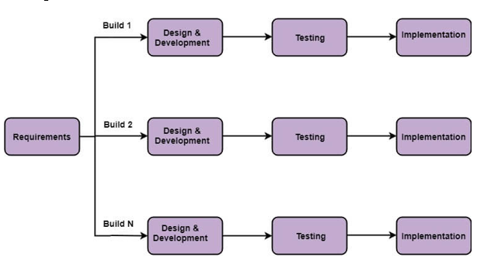
Figure 1.1: Incremental Model for Railway Reservation System
The Incremental Model is chosen for the development of the Railway Reservation System because it provides a flexible, phased, and structured approach to building complex software systems. The railway reservation system consists of multiple interdependent modules such as user registration, ticket booking, seat availability, payment processing, and cancellation handling which can be developed and delivered one at a time.Additionally, the railway system often evolves over time due to policy changes, user needs, or integration with new technologies (like online payment systems). The Incremental Model is highly adaptable to changing requirements, allowing for the addition of new features in future increments without redesigning the entire system.

Report Organization
Introduction
This chapter deals with the introduction of the system with its objectives and limitations along with the reason why the system is made.
Background Study and Literature Review
This chapter summarizes the work that has been carried out in this field and also describes the features about some existing applications related to the railway reservation system.
System Analysis and Design
This chapter focuses on the different requirement of the system, which describes about the functional, non-functional, feasibility analysis, Object Modeling (Object and Class Diagram), Dynamic Modeling (State and Sequential Diagram), Process Modeling (Activity Diagram) design of the system with Component Diagram, Deployment Diagram, Refinement of classes and object and the implementation of Algorithm with its details.
Implementation and Testing
Different tools for implementing the system like case tools, programming language, database platforms are included in this chapter. Similarly, testing of different module and testing as a software are also included here. Result analysis of multiple models with their performance scores, along with visualizations to make results easier to understand are also included in this chapter.
Conclusion and Future Recommendation
This chapter contains the lesson learned in the system development process, system outcome and conclusion are noted here. Likewise, the future recommendation and enhancement part from the developer perspective are also listed under this chapter.

CHAPTER 2: BACKGROUND STUDY AND LITERATURE REVIEW

2.1 Background Study
The Railway Reservation System is a software-based solution developed to automate the process of booking and managing train tickets. Traditionally, the railway ticket booking system was operated manually, where passengers had to visit railway stations and stand in long queues to fill booking forms and wait for confirmation from ticket clerks. This process was not only time-consuming but also prone to human errors, overbooking, and data mismanagement.
With the advancement in information technology, the demand for faster and more efficient services grew, especially in public transportation systems like railways. This led to the development of computerized reservation systems, which transformed the manual ticketing process into a digitally managed and automated system. These systems are now capable of handling large-scale reservations, checking real-time seat availability, managing train schedules, processing online payments, and generating instant confirmations.
The primary goal of such a system is to make the ticket booking experience convenient, fast, and reliable for passengers, while also reducing the workload on railway staff.

2.2 Literature Review
A literature review provides a detailed overview of existing research, systems, and technological advancements related to a specific topic-in this case, the Railway Reservation System. It helps to understand how current systems have evolved over time, what technologies have been used, their limitations, and the opportunities for further improvement.
Online Railway Reservation System Design and Implementation A study by Sharma et al. (2013) developed a web-based railway reservation system that automated ticket booking, seat availability, and train schedule management. The system used PHP and MySQL for front-end and database operations. The study emphasized the reduction in manual work, prevention of overbooking, and real-time updates for users.[1]
Automated Ticketing and Passenger Information System for Indian Railways Conducted by Verma et al. (2015), this project integrated RFID and GSM modules to automatically verify passenger tickets and send SMS alerts. It enhanced both security and passenger convenience. The research suggested that automating information delivery improves customer satisfaction and decreases human errors at railway stations.[2]
IRCTC Reservation System Analysis A technical report analyzing the IRCTC (Indian Railway Catering and Tourism Corporation) system discussed its architecture, peak-time load handling, and security layers. The study highlighted the use of cloud infrastructure, payment gateway integration, and session management to maintain system uptime during high traffic, especially during festival seasons and special ticket bookings.
Mobile-Based Reservation Applications With increasing smartphone usage, research by Ranjan et al. (2017) proposed an Android-based railway reservation app that allowed users to book tickets, cancel reservations, check train routes, and track PNR status. The system also included QR code-based ticket validation for improved boarding efficiency.[3]
Data Mining in Railway Systems A data-centric study by Kumar & Mishra (2019) explored how data mining techniques can be used to analyze passenger booking behavior and predict high-demand routes or times. This information helps optimize train scheduling, resource allocation, and ticket pricing. The study demonstrated the potential of intelligent analytics in enhancing railway operations.[4]
Intelligent Railway Ticket Reservation System Using Cloud Computing Patel and Mehta (2018) proposed a cloud-based reservation architecture where resources such as seat availability, fare calculation, and route mapping were dynamically managed using Infrastructure-as-a-Service (IaaS). Their system allowed for high availability, better fault tolerance, and faster scalability, especially during high-demand periods. It also reduced infrastructure costs for the railway operators.[5]
Enhancing Railway Booking Systems Using Blockchain Technology A study by Joshi et al. (2020) explored the integration of blockchain in ticket booking to ensure tamper-proof transactions and transparent cancellation/refund policies. It tackled issues like ticket fraud, double booking, and system tampering by storing each transaction in a decentralized ledger. The study indicated improved trust, traceability, and accountability in railway operations.[6]

CHAPTER 3: SYSTEM ANALYSIS AND DESIGN

3.1 System Analysis
In this process of system designing many steps were taken into considerations. Among those steps, analyzing the system was one of the major steps. Different functional requirement, non- functional requirement discussion and feasibility study was implemented as a part of system analysis.

3.1.1 Requirement Analysis
Requirement analysis is a critical phase in software development where all the needs and expectations of stakeholders are gathered, analyzed, and documented. For a Railway Reservation System, it involves understanding the functions the system must perform such as booking tickets, checking availability, or canceling reservations as well as performance, reliability, and security standards.

Functional Requirement
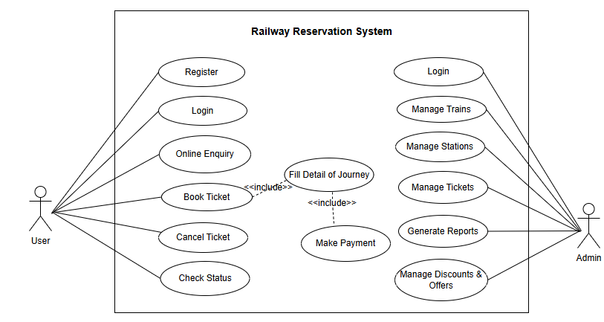
Figure 3.1: Use Case Diagram for Railway Reservation System
The use case diagram shows the interaction between the system and its external actors. Two actors are defined: User and Administrator. The User interacts with the system to search trains, check availability, book or cancel tickets, and make payments. The Administrator performs system-level tasks like managing train schedules, user accounts, and monitoring bookings. The diagram helps to understand how different users interact with the system.

Non-Functional Requirement
System attributes such as security, performance, reliability, etc. are defined by nonfunctional requirements. They ensure the whole system's performance and usability. If any one of them is not met, the system may not be able to meet the needs of the user. The following is a list of some of the non-functional requirements:
• Performance: The system provides fast response times, ensuring that the results load quickly.
• Usability: The system is easy to use and navigate, with a friendly interface that allows users to search the train easily.
• Reliability: The system is reliable, available, and accessible 24/7.
• Security: The system is secure as it uses data encryption and passwords protection.
• Maintainability: As the code is written in a clear and readable format, making the system simple to maintain and update in the future.

3.1.2 Feasibility Study
A feasibility Study is a test of the system according to its workability, impact of the organization, ability to meet user needs, and effective use of the resources. A Feasibility Study is generic in nature and can be applied to any type of project, be it for systems and software development, making an acquisition, or any other project. We can test the system with different types of feasibilities.

Technical Feasibility
Technical feasibility determines whether the work for the project can be done with the existing equipment, software technology and available personnel. As this project is created using an open-source and free tool, the hardware and software used to create it is at the cutting edge of technology. Therefore, there is not any technological challenges while developing this system.

Operational Feasibility
The system is easy to operate with the basic knowledge of computer and internet and well-trained manpower is not necessary. User can also easily access the system as it is user friendly in many aspects with good User Interface (UI).

Economic Feasibility
The system is economically feasible and cost effective. As all the tools and resources required are either open sources or free. After the completion of the system organization didn’t need to deploy any new hardware and software as the required software and hardware. The existing resource of the system can be used.

Schedule Feasibility
The system is also very much feasible in term of schedule. The particular time period is divided for each phases and we will complete the project within the given time period. Every phases like requirement analysis, design, development, testing, implementation and documentation have their particular time period and have each documentation period.
Table 3. 1 Gantt Chart of Railway Reservation System
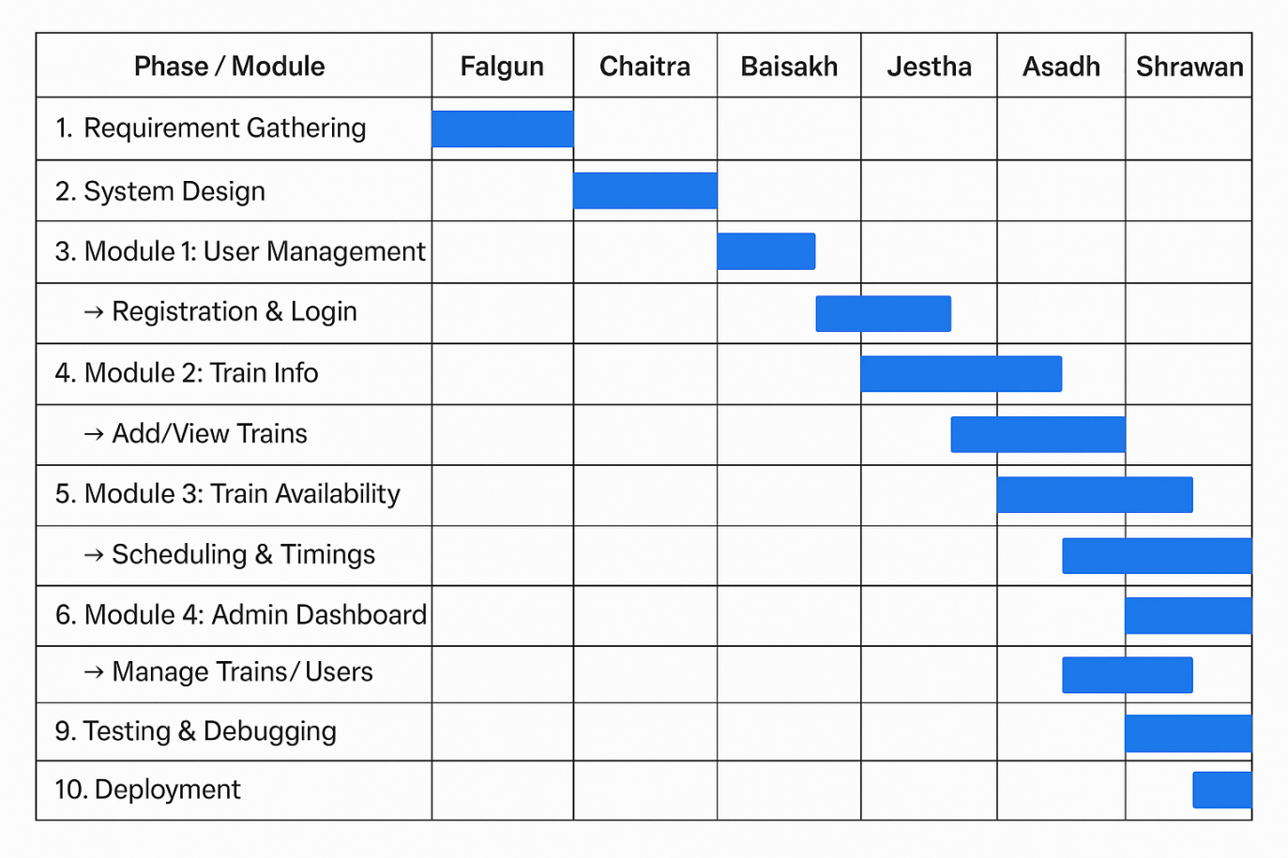

3.1.3 Object Modelling: Class & Object Diagram
The structure and behaviour of the proposed system is shown in the UML class diagram below.There are 5 classes present in the diagram they are User, Admin, Trains, Bookings, TrainAvailabilities classes. Each class contains characteristics and behaviors defined by methods and attributes. The diagram also demonstrates how the classes are connected to one another by various forms of relations, which are represented by various lines. The relationship types employed in this diagram includes inheritance and aggregation. The admin class inherits or extends methods and attributes from user class. User and Admin class shares name, email,age, password attributes and register, login and logout methods. But admin class have unique is_admin attribute and manage users, update train, update stations methods. There are four classes that have aggregation relation they are: User, Booking, Admin, TrainAvailabilities . This relation represents that one class is part of another class but exists independently.
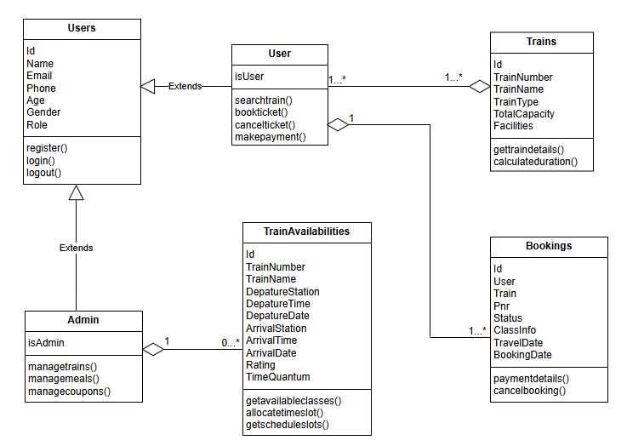
Figure 3.2: Class Diagram of Railway Reservation System
The diagram below is the object diagram of Railway Reservation System, which represents the relationship between different classes in a system. As there are mainly five classes: User, Admin, Trains, Bookings and TrainAvailabilities. The attributes of each classes are labeled in the diagram below. For example, user class has attributes of name, email,age,password etc., For example, the admin class is related with TrainAvailabilities with zero or more than one relationship and also aggregation relationship, which means that these classes are related with each other but can exists independently.
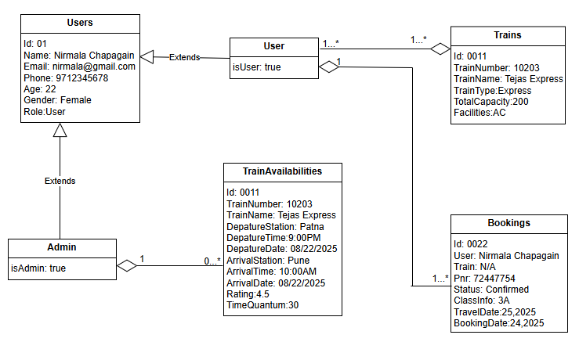
Figure 3.3: Object Diagram of Railway Reservation System

3.1.4 Dynamic Modelling: State & Sequence Diagram

State Diagram:
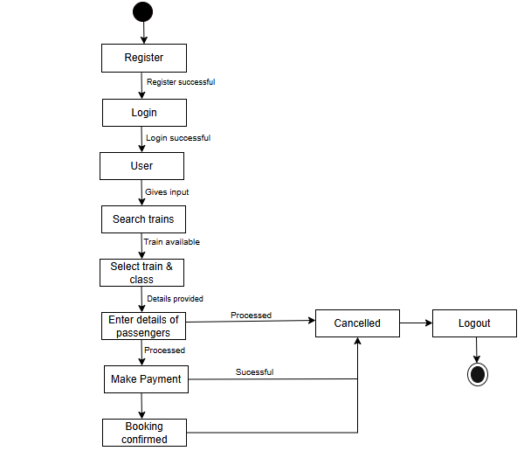
Figure 3.4: State Diagram of Railway Reservation System
The above state diagram illustrates the flow of a user’s interaction with a system that involves registration, login, train selection,payment process, and logout functionalities. The workflows begin at the initial state represented by a solid black dot, where user enters the required information to register. When the registration process is completed successfully, as shown by the condition “Registration complete” the user is taken to the login state.
In the login state, the user enters their credentials. If the login is successful, as shown by the condition “Login Successful”, the user then moves to user state.
Sequence Diagram:
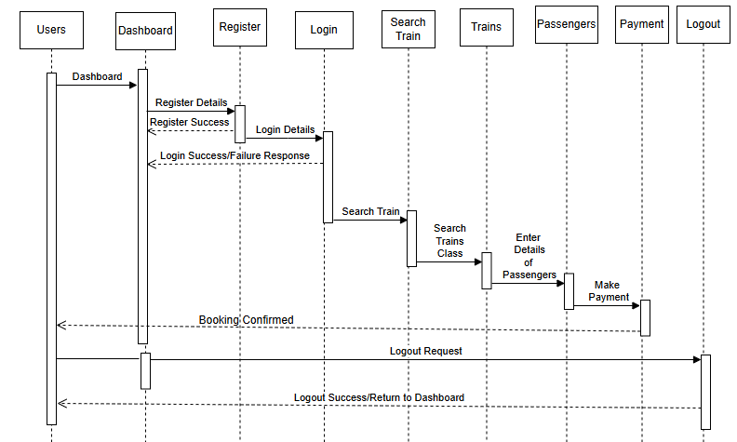
Figure3.5: Sequence Diagram of Railway Reservation System
The sequence diagram for the Railway Reservation System illustrates the interaction flow between the user and system components to facilitate train ticket booking and management. The process begins with the user registering and logging into the system, ensuring secure access and personalized usage. After successful authentication, the user is directed to the dashboard, where they can perform various actions such as searching for available trains, viewing schedules, and initiating bookings.
This sequence diagram captures the primary operations involved in a railway reservation system, including user authentication, train search, booking, seat allocation, and logout. It emphasizes modularity by representing each major action registration, login, train search, booking request, seat confirmation, payment processing, and logout as distinct interactions. This approach not only ensures clarity but also promotes maintainability and scalability of the system. The workflow aligns with real-world reservation systems used in modern railway networks, where real-time data and user-centric design are crucial for efficient and seamless service delivery.

3.1.5 Process Modelling: Activity Diagram
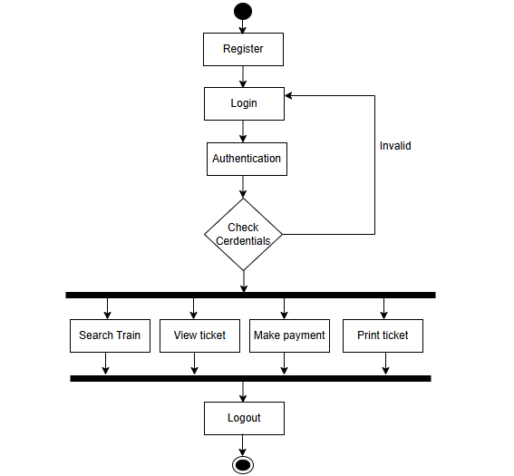
Figure 3.6: Activity Diagram of Railway Reservation System for User
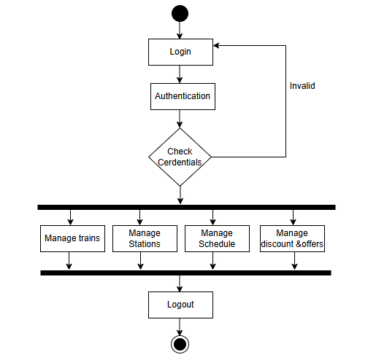
Figure 3 .7: Activity Diagram of Railway Reservation System for Admin
The activity diagrams above represent the process from sign up, sign in to sign out in Railway Reservation System. The process starts with the black dot that represents the initial state or the start point of the activity. For the user, register is the first process after the application has started. This process is represented by rectangle with rounded corners. After that leads to the login process where all the checking of credentials performed. This login process is same for admin also. If the credentials are correct then both the admin and user are redirected to their respective dashboards. If the credentials are incorrect then the are redirected to login process again. The user can either view tickets or search train. Likewise, after entering in admin dashboard, the admin can manage meals, trains, stations . The admin can update user role or delete users from manage users. Admin can also manage trains by adding, deleting or updating them.

3.2 System Design

3.2.1 Refinement of Class and Objects
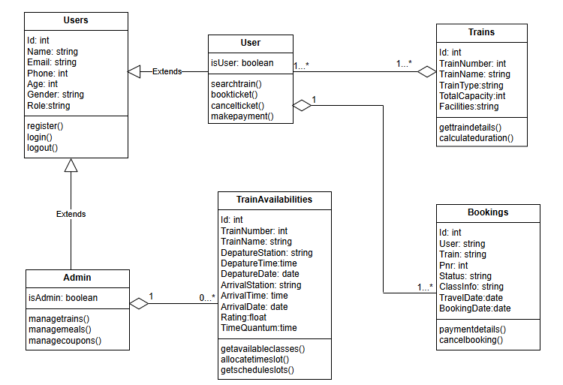
Figure 3 .8: Refinement of Classes and Objects of Railway Reservation System
Railway Reservation System, refinement of class diagram involves making detailed Adjustment or improvement to the diagram to provide more specific and precise information about the classes, their attributes, methods and relationships. In above diagram, there is a notation of visibility for each attribute and operations like public and private. In the system there are five classes named users, admin, trains, bookings, trainavailabilities.The attributes in all class has private access modifier except train class. The train class have public access modifier.All the data types (String, int, Boolean, etc.,) of attributes present in the classes are also labeled in the diagram. The users class contains public access modifier login, register and logout methods.

3.2.2 Component Diagram
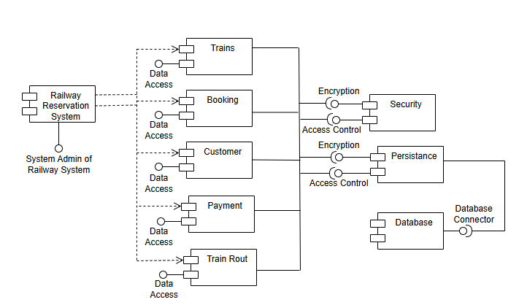
Figure 3 .9: Component Diagram of Railway Reservation System
The component diagram for the Railway Reservation System illustrates how the various parts of the system interact with each other to perform essential operations such as managing train information, checking seat availability, booking tickets, and processing payments. It represents the high-level software components and their relationships in a modular way.
The Admin component manages the backend of the system. It is responsible for adding and updating train details, managing user data, and modifying availability schedules. Admin interacts directly with the Train Management and Train Availability components.The Booking System component is central to the reservation process. It handles booking requests, manages passenger details, class selection, and meal options, and confirms bookings based on availability and payment confirmation.The Payment and component processes payment transactions. It communicates with the Booking System to complete the reservation process.

3.2.3 Deployment Diagram
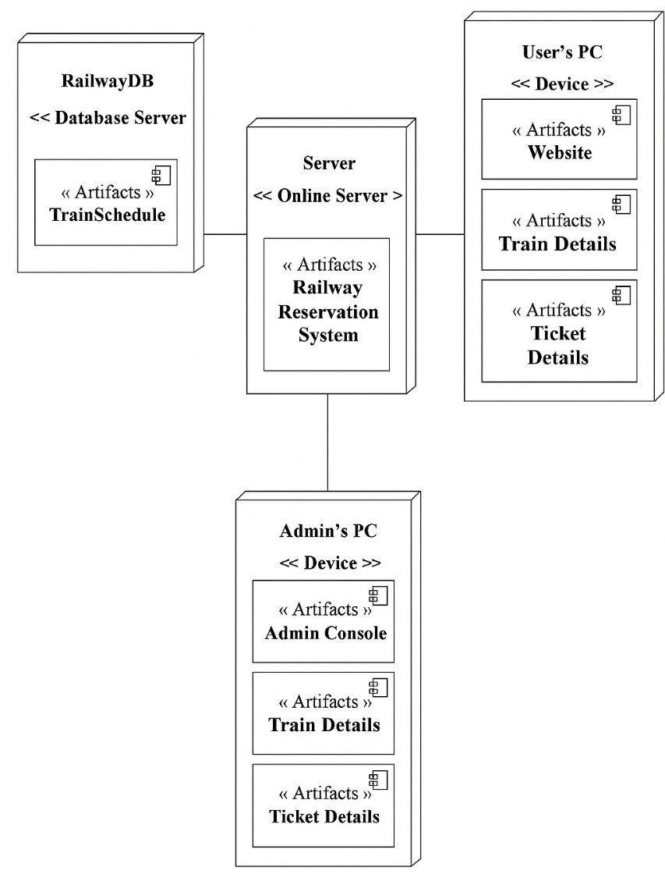
Figure 3 .10: Deployment Diagram of Railway Reservation System
The deployment diagram above represents the relationship between different nodes and components of the system. The system consists of four nodes: Railway Reservation System p server, database server, admin and user nodes. The database server node is Responsible for storing users and trains information.The database server node is connected to Railway Reservation System server through the association relation. The server node is responsible for processing information provided by the users, such as authentication, searching train lists, payment process, etc., The server node is connected to the database server node, user node and admin node with an association relation. This node also processes users, tickets, and train information provided by the admin. The admin node is responsible for showing the admin dashboard, which consist of processes to manage users, trains, payment and stations. The admin node is connected to server node and database node with an association relationship. The user node is responsible for accessing to the system, from which the user can see train lists, tickets, etc., The user node is connected to the database and server node through the association relationship.

3.3 Algorithm
The Railway Reservation System employs the Round Robin Scheduling Algorithm to fairly handle multiple seat booking requests, especially during high-demand periods. This algorithm ensures that no single request monopolizes the system, allowing each user to get a fair chance at booking available seats. It’s suitable for time-sharing and multitasking environments, making it ideal for high-traffic booking systems.
Round Robin Scheduling
Round Robin plays a key role in the seat allocation mechanism by providing an organized and non-blocking approach for concurrent bookings, which improves user satisfaction and system stability.It allocates resources (in this case, train seats) by cycling through user requests one at a time. It prevents overbooking by any one user and handles all requests uniformly and efficiently, especially under load.
How it works?
Step 1: Input Booking Data
- Collect all the bookings made by users.
- Each booking contains:
Id (Booking ID)
arrivalTime(when the booking request was made)
Step 2: Set the Time Quantum
- Define the time quantum a fixed time slot given to each booking.
Example:timeQuantum= 30 minutes
Step 3: Initialize the System
- Set:
currentTime= 0
resultList= [] to store processed booking data
Step 4: Process Each Booking in Order
Loop through each booking (in arrival order):
- Start Time= Current System Time
- Wait Time= Start Time-Arrival Time
- Completion Time= Start Time + Time Quantum
- Turnaround Time= Completion Time - Arrival Time
- Save all this information in a result object
- Move currentTime= CompletionTime
Step 5: Store Result of Each Booking
Store for each booking:
BookingID ArrivalTime StartTime CompletionTime WaitTime TurnaroundTime
Step 6: Repeat Until All Booking are Processed
- Continue the loop for each booking
- Make sure no booking is skipped
- Use a First-In-First-Out(FIFO) circular queue approach.
Step 7: Calculate Final Performance Metrics
After processing all bookings,calculate:
- Total Wait Time= ∑(Start Time - Arrival Time)
- Total Turnaround Time= ∑(Turnaround Time)
- Average Wait Time= Total Wait Time / Number of bookings
- Average Turnaround Time= Total Turnaround Time / Numbers of bookings
- CPU Utilization= Total Time Used for Processing / Total Completion Time * 100
- Throughput= Number of bookings / Total Time in Minutes * 60

CHAPTER 4: IMPLEMENTATION AND TESTING

4.1 Implementation
The actual coding of different modules and function for Railway Reservation System are take place in this phase. Different modules and components are coded according to the specifications outlined in the system design phase. Integration of various modules and components is carried out to ensure that they work together seamlessly.

4.1.1 Tools Used
The Railway Reservation System was developed using a modern and efficient technology stack. Each tool, framework, and language played a specific role in making the application scalable, responsive, and easy to use. The system is built following the MVC (Model-View-Controller) architecture to separate concerns in development, allowing for better management and modularity.The following design and development tool made the process easier.
React JS: The frontend of the application is developed using React.js, a popular JavaScript library for building user interfaces. It allows developers to create reusable components, resulting in a dynamic and responsive UI. Both the user interface (for booking and searching trains) and the admin interface (for managing trains and schedules) are built using React. It helps update only the required parts of the page, without reloading the entire page, enhancing performance and user experience.
Context API & Axios: To facilitate communication between the frontend and backend, the system uses RESTful APIs developed in Node.js. These APIs allow users to perform operations like searching trains, booking tickets, viewing bookings, and cancelling reservations. The Axios library is used on the frontend to send HTTP requests to these APIs, while Context API is used for managing the application state such as user data, booking status, and login status.
Node JS: The server-side logic is handled by Node.js, a runtime environment for executing JavaScript code outside the browser. It is responsible for processing requests from the frontend, applying business logic, and responding to client requests. In this system, Node.js is used to implement the Round Robin scheduling algorithm, manage bookings, allocate seats, and handle authentication. The backend also manages routing and acts as a bridge between the database and the frontend.
MongoDB: The application uses MongoDB, a NoSQL database, to store all the data required by the system. This includes information like train schedules, seat availability, booking records, and user details. MongoDB stores data in a flexible, document-oriented format (JSON), which makes it easier to handle various types of records without a fixed schema.It ensures fast retrieval and scalability for a system handling multiple simultaneous bookings.

4.1.2 Implementation Details of the Modules.
The system named “Railway Reservation System” uses different modules. A module is a software component or part of a program that contains one or more routines. The implementation of these modules plays a crucial role overall functionality and success of the application.These modules are:
- Registration Module: The Registration Module is a fundamental component of the railway reservation system. It is the gateway through which users (passengers, admins, or staff) first interact with the system by creating a secure and unique user account. This module ensures a personalized and secure experience, enabling user-specific operations such as booking tickets, viewing history, or managing trains.
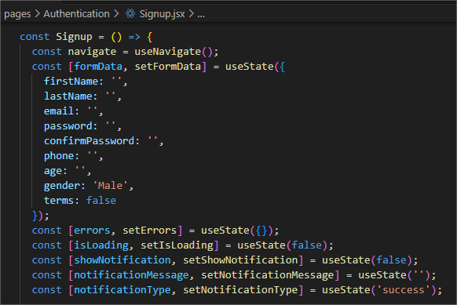
Figure 4.1: Registration Module of Railway Reservation System
- Login Module: The Login Module in a Railway Reservation System is responsible for verifying the identity of users (passengers, admins, or agents) by authenticating their credentials. It ensures that only registered and authorized users can access protected functionalities like booking tickets, canceling reservations, or managing train schedules.
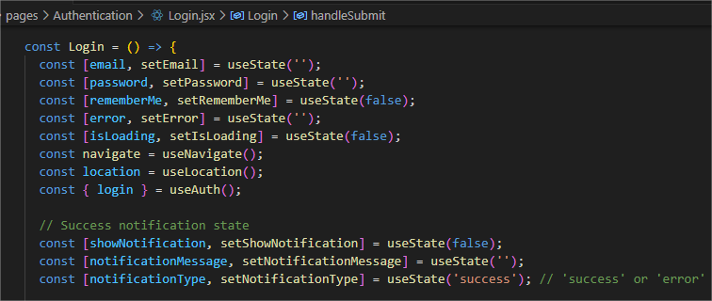
Figure 4.2: Login Module of Railway Reservation System
- Dashboard Module: The dashboard module provides a centralized interface for users after successful authentication. It displays personalized content based on the user’s role. Regular users (passengers) can access features such as profile management, train search, booking history, and ticket cancellation. Administrators are provided with advanced controls to manage users, trains, schedules, and monitor booking activities. This module ensures that each user interacts with the system functionalities relevant to their role, enhancing usability and system organization.
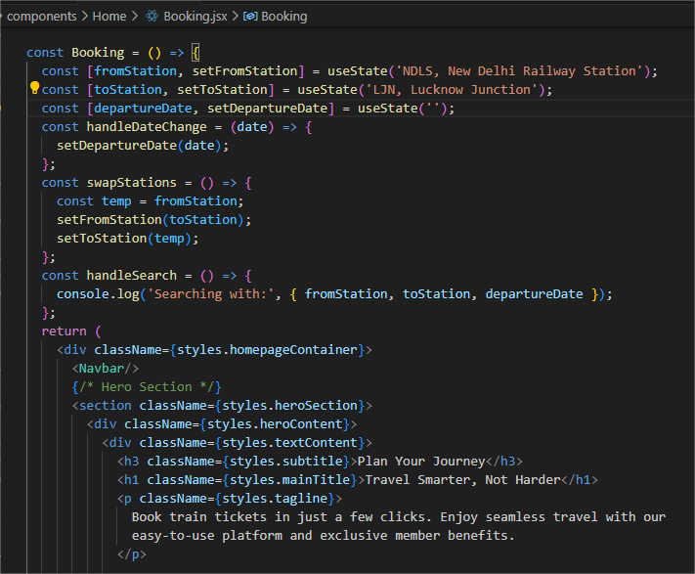
Figure 4.3: Dashboard Module of Railway Reservation System
- Trains Module: The Train Module is responsible for managing and retrieving information related to the trains available in the railway reservation system. This module allows users to access essential train data such as train names, numbers, routes, timings, and other basic information.
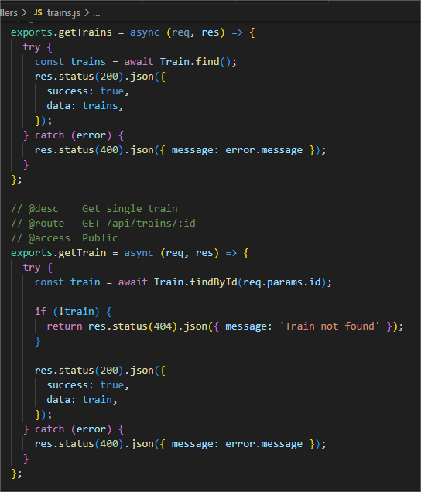
Figure 4.4: Trains Module of Railway Reservation System
- Booking Module: The Booking Module is a critical component of the Railway Reservation System responsible for handling the reservation of seats on trains. It manages user booking requests by validating input, checking train availability, applying optional services, and preparing the booking for finalization and payment.
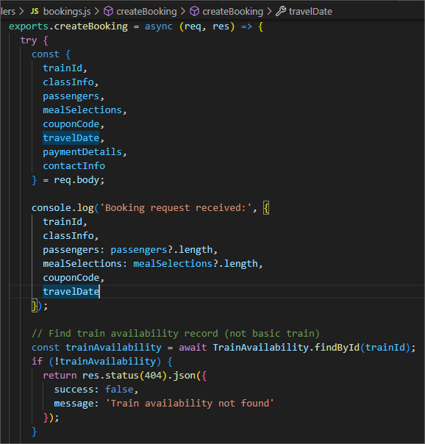
Figure 4.5: Booking Module of Railway Reservation System
- Trainavailability Module: The Train Availability Module is responsible for managing and delivering real-time data about train schedules, available seats, classes, and service status. It ensures that users and the system have up-to-date information about trains before making a reservation.
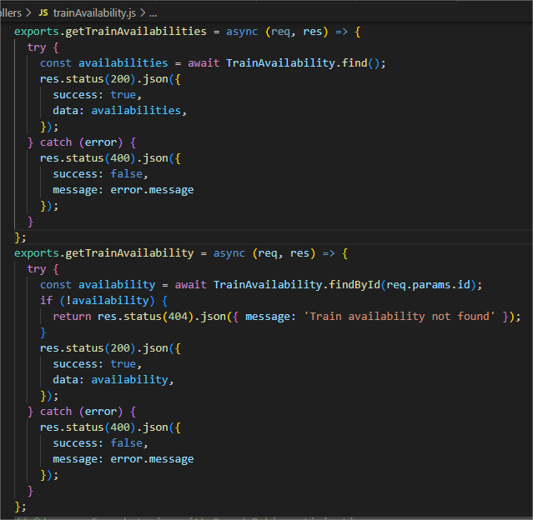
Figure 4.6: Trainavailability Module of Railway Reservation System

4.2 Testing
Testing is the utter most requirement to check the quality and capacity of the system. The Railway Reservation System is also tested through different test case. The testing is done on Railway Reservation System gives the accurate result as per their works. The series of testing conducted are as follow:

4.2.1 Test Case for Unit Testing
Unit testing is the part of the testing methodology which includes testing of individual software modules. We also performed different unit testing on the individual modules of the Railway Reservation System.
Table 4.1 Test Case for Starting the Server
Test Case ID | Description | Input Test data | Expected Result | Actual Result | Pass/Fail
TC1.1 | Start client, backend and database in terminal. | Frontend Command=npm run dev  url= http://localhost:  5173  Backend Command=npm run dev  url= http://localhost:  5174  Database Command=npm run dev  url= http://localhost:  5002 | All the server should run without any issue. | All the three servers run successfully without any issues. | Pass

Table 4.2 Test Case for User Registration
Test Case ID | Description | Input Test Data | Expected Result | Actual Result | Pass/Fail
TC2.1 | Navigating to home and displaying home page. | Enter Frontend  url= http://localhost:  5173 | Home page should displayed with navigating bar. | Home page is shown with navigating bar to navigate to different page. | Pass
TC2.2 | Navigating to register page. | Click on register tab on navbar. | Registration page with register form should be displayed. | Registration page with register form was displayed. | Pass
TC2.3 | Register with filling required fields. | First Name: Nirmala  Second Name: Chapagain  Email: nirmala12@  gmail.com  Age: 22  Phone : 9712345678  Gender: Female  Password: Nirmala1# | Registration  create successfully. | Registration successful! Please login with your credentials. | Pass
TC2.4 | Register with incorrect or empty fields. | First Name: Kalyan  Second Name: Chapagain  Email: ####  Age: 12  Phone: 9812345678  Gender: Male  Password: | Error message must be displayed. | Error: Invalid details.  Error: Please enter required fields. | Pass

Table 4.3 Test Case for User Login
Test Case ID | Description | Input Test Data | Expected Result | Actual Result | Pass/Fail
TC3.1 | Navigating to login page. | Click on login tab on navbar. | Login page with login form should be displayed. | Login page with login form was displayed. | Pass
TC3.2 | Login with correct email and password. | Email: nirmala12@  gmail.com  Password: Nirmala1# | Should be redirected to respective dashboard. | Redirected to user dashboard. | Pass
TC3.3 | Login with empty fields. | Email:  Password: | Error message must be displayed. | Error: Please enter required fields. | Pass
TC3.4 | Login with incorrect email and password.. | Email: ####  Password: nirmala | Error message must be displayed. | Error: Invalid credentials. | Pass

Table 4.4 Test Case for Booking Train
Test Case ID | Description | Input Test Data | Expected Result | Actual Result | Pass/Fail
TC4.1 | Navigating to dashboard. | Click Serach Train button. | TrainView page should be displayed with available trains details. | TrainView page was displayed with available trains details. | Pass
TC4.2 | Click Book Now Button. | Click Book Now Butoon after selecting available train. | Reviewbooking page with traveler details, payment method should be displayed. | Reviewbooking page with traveler details, payment method was displayed. | Pass
TC4.3 | Add traveler details & payment method 1 | Full Name: Nirmala Chapagain  Age: 23  Gender: Female  Nationality: Nepali  Mobile: 9712345678  Email: nirmala12@gmail.com  Payment method: PayPal | Click Procced To Payment button to complete the payment. | Click Procced To Payment button to complete the payment. | Pass
TC4.4 | Add traveler details & payment method 2 | Full Name: Nirmala Chapagain  Age: 23  Gender: Female  Nationality: Nepali  Mobile: 9712345678  Email:  Payment method: PayPal | Error message must be displayed. | Error: Email is required. | Pass

Table 4.5 Test Case for Admin Login
Test Case ID | Description | Input Test Data | Expected Result | Actual Result | Pass/Fail
TC5.1 | Navigating to login page. | Enter backend url= http://localhost:5174 | Login page with login form should be displayed. | Login page with login form was displayed. | Pass
TC5.2 | Login with correct email and password. | Email: admin@train.com  Password: @Admin123 | Should be redirected to admin panel.. | Redirected to admin panel. | Pass
TC5.3 | Login with empty fields. | Email:  Password: | Error message must be displayed. | Error: Please enter required fields. | Pass
TC5.4 | Login with incorrect email and password.. | Email: @@@@  Password: kalyan | Error message must be displayed. | Error: Invalid credentials. | Pass

Table 4.6 Test Case for Adding Train
Test Case ID | Description | Input Test Data | Expected Result | Actual Result | Pass/Fail
TC6.1 | Open admin panel. | Click on trains tab on sidebar. | Trains page with train list should be displayed. | Trains page with train list was displayed. | Pass
TC6.2 | Click Add New Train button. | Click Add New Train button on navbar to add train. | Page is expected to display train information. | Page is display  with train details. | Pass
TC6.3 | Add  Train 1 | Train Number: 11023  Train Name: Tejas Express  Train Type: Express  Total Capacity:100  Facilities: AC,WIFI | Train added successfully. | Train added successfully. | Pass
TC6.4 | Add  Train 2 | Train Number: 11024  Train Name:  Train Type: Express  Total Capacity:200  Facilities: AC,WIFI | Error message must be displayed. | Error: Train Name is required. | Pass

Table 4.7 Test Case for Creating Schedule
Test Case ID | Description | Input Test Data | Expected Result | Actual Result | Pass/Fail
TC6.1 | Open admin panel. | Click on scheduling tab on sidebar. | Train-availability page with train route & schedule should be displayed. | Train-availability page with train route & schedule was displayed. | Pass
TC6.2 | Click Create New Schedule. | Click Create New Schedule on navbar to create new route & schedule. | Page is expected to display route & schedule information. | Page is display  with route & schedule details. | Pass
TC6.3 | Create  Route & Schedule 1 | Departure station: New Delhi  Arrival station: Mumbai  Departure date: 08/20/2025  Arrival date: 08/21/2025  Departure time:10:00PM  Arrival time:9:00AM  Duration:11:00hrs | Scheduling created successfully. | Scheduling created successfully. | Pass
TC6.4 | Create  Route & Schedule 2 | Departure station: Kolkota,HWH  Arrival station:  Departure date: 08/25/2025  Arrival date: 08/26/2025  Departure time: 11:00PM  Arrival time: 10:00AM  Duration:11:00hrs | Error message must be displayed. | Error: Arrival Station is required. | Pass

4.2.2 Test Case for System Testing
The Railway Reservation System is also undergone through the system testing where after integration of every module and unit of the system. The test case for testing the system functionality is working correctly or not after integration.
Table 4.8 Black Box System Testing
S.N | Description | Requirements | Result | Test Status
1. | Authentication | User provides valid registration details(name,email,password,phone number,age,gender). | User can create new account and sign in to the system for booking train. | Passed
2. | View Trains | Search query( trains,seats etc.). | Both unauthenticated and authenticated user can view the trains list and train details. | Passed
3. | Booking train | Authentication with correct details is required to book train. | Authenticated user an book trains with systematic features. | Passed
4. | Add trains | Admin role with admin login credentials and train details(e.g. train number, train name,train type,facilities). | Admin can add,update,view and delete train details. | Passed
5. | Manage Coupons & Meals | Admin role with admin login credentials and coupons & meals details. | Admin can update coupons & meals roles from admin to user and vice versa. | Passed

CHAPTER 5: CONCLUSION ANDFUTURE RECOMMENDATION

5.1 Lesson Learnt/Outcomes
In Railway Reservation System project, we gained valuable insights into building real-world applications. We learned the importance of data consistency, efficient database design, and applying scheduling algorithms like Round Robin. The project highlighted the need for a user-friendly interface and secure authentication to protect user data. Additionally, it improved our skills in testing, teamwork, and project management, making the development process both educational and rewarding.
The development of the Railway Reservation System provided both technical and professional growth opportunities. The key outcomes acquired during and after the project are as follows:
- Leadership in Software Development
The project enabled us to apply theoretical knowledge of software development methodologies in a practical context. We learned how to plan, organize, and lead the development process effectively, ensuring smooth progress through each phase of the software development life cycle (SDLC).
- Teamwork and Collaboration
As a group project, it emphasized the importance of collaboration. We developed skills in team coordination, task allocation, communication, and collective problem-solving essential abilities for any real-world software development environment.
- Use of CASE Tools
We used Computer-Aided Software Engineering (CASE) tools such as draw.io to design and model various system components. Diagrams like the Entity-Relationship (ER) diagram, Data Flow Diagram (DFD), Use Case Diagram, Context Diagram, and Database Schema were created to support system analysis and design.
- Programming and Problem-Solving Skills
Developing the Railway Reservation System required writing and debugging code in a real-time environment. This enhanced our programming capabilities and critical thinking as we resolved logic errors, handled edge cases, and ensured the application functioned correctly under all conditions.
- Documentation and Presentation Skills
We followed structured documentation standards while preparing the project report, which improved our technical writing skills. Additionally, presenting the project helped strengthen our confidence and communication abilities.
- Software Testing and Validation
A variety of test cases were designed and executed to verify the correctness and reliability of the system. This deepened our understanding of software testing methodologies and highlighted the importance of rigorous validation in software projects.

5.2 Conclusion
The development of the Railway Reservation System has been a valuable learning experience that successfully met its key objectives. The system provides an efficient and user-friendly platform for passengers to book train tickets, check seat availability, and manage reservations seamlessly.With a centralized admin dashboard, the system ensures smooth management of trains, schedules, and user data. It effectively handles real-time seat allocation, cancellations, and booking updates, ensuring data consistency and reliability.
By integrating scheduling algorithms and robust database design, the system offers fair resource allocation and fast processing, improving the overall user experience. Additionally, built-in security measures safeguard sensitive information, promoting trust and privacy.Overall, the Railway Reservation System delivers a practical solution that enhances operational efficiency for railway services while providing convenience and reliability to users.

Future Recommendation
To enhance the Railway Reservation System, developing a mobile application would be highly beneficial, providing passengers with easy access to booking services, schedule information, and real-time updates right from their smartphones. Incorporating secure electronic payment options such as mobile wallets, internet banking, and UPI will streamline the booking process and encourage cashless transactions. Real-time train tracking and notification systems can improve passenger experience by delivering timely alerts about train locations, delays, and platform changes. Additionally, features like dynamic seat allocation, waitlist management, and automatic seat upgrades would offer more flexible and convenient booking options, increasing customer satisfaction.
Furthermore, adding multi-language support would make the system more accessible to users from diverse regions. Enhancing security with measures such as two-factor authentication and fraud detection will help protect user data and prevent unauthorized bookings. Together, these improvements will create a more efficient, secure, and user-friendly platform, addressing the evolving needs of modern railway passengers and administrators alike.

REFERENCES

[1] | Sharma et al , "Online Railway Reservation System Design and Implementation".
[2] | Verma et al, "Automated Ticketing and Passenger Information System for Indian Railway".
[3] | Rajan et al, "Mobile-Based Reservation Apllication".
[4]  [5]  [6] | Kumar & Mishra, "Data Mining in Railway System" .  Patel and Mehta,"Intelligent Railway Ticket Reservation System using Cloud Computing".  Joshi et al,"Enhancing Railway Booking System using Blockchain Technology".

APPENDICES
Trains Details -User Role
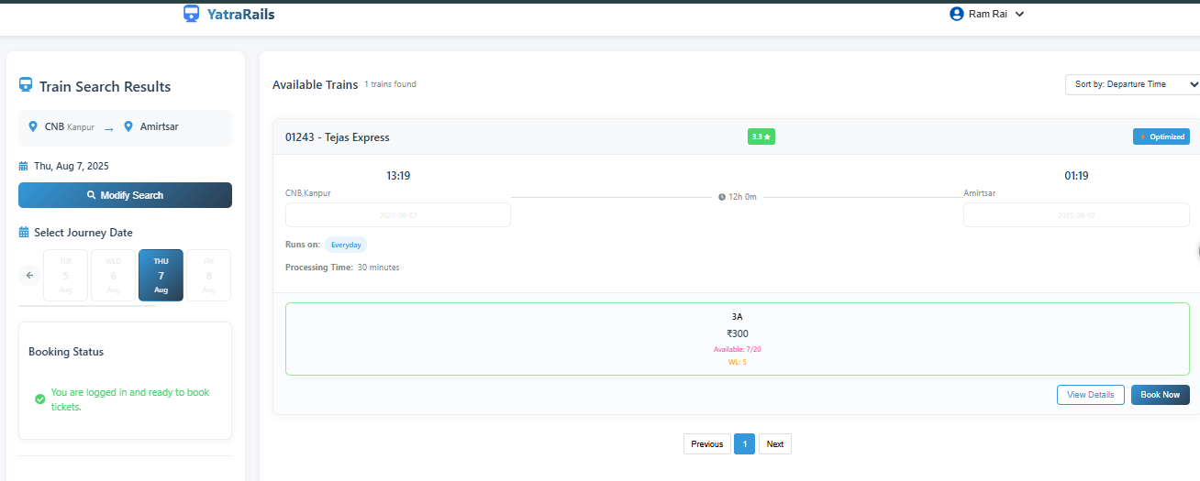

Book train- User Role
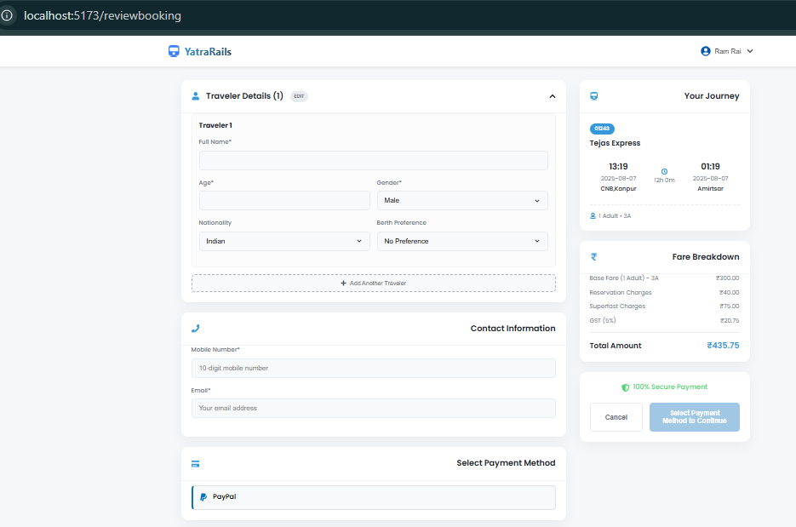

Booking Confirmed after Payment Method
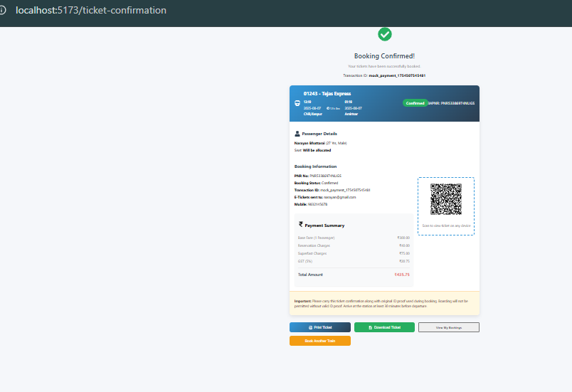
Print Ticket - User Role
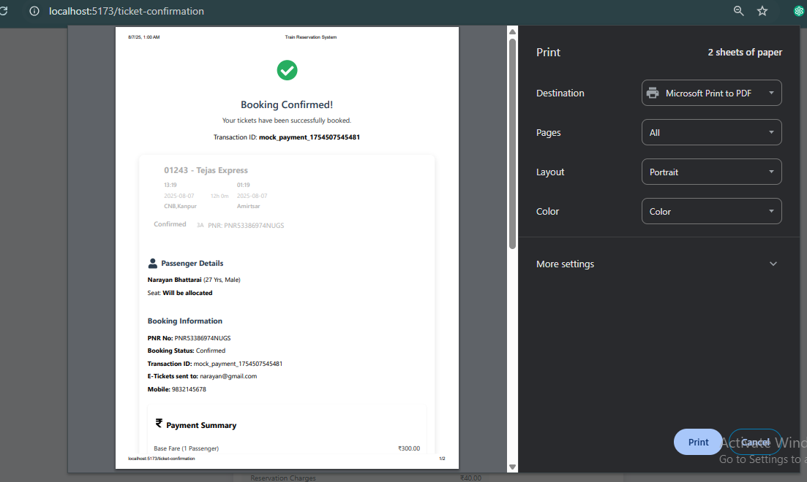

View Profile- User Role
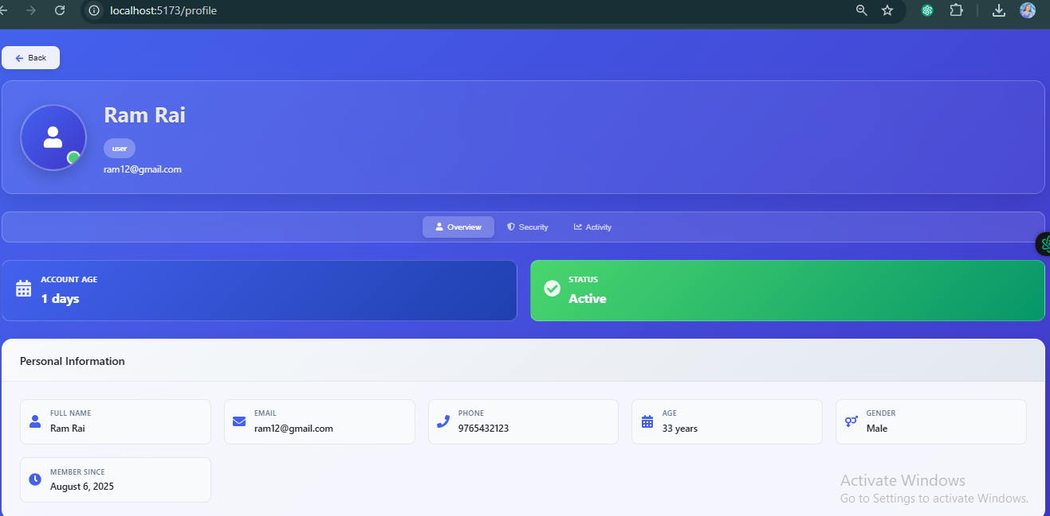

Add Train- Admin Role
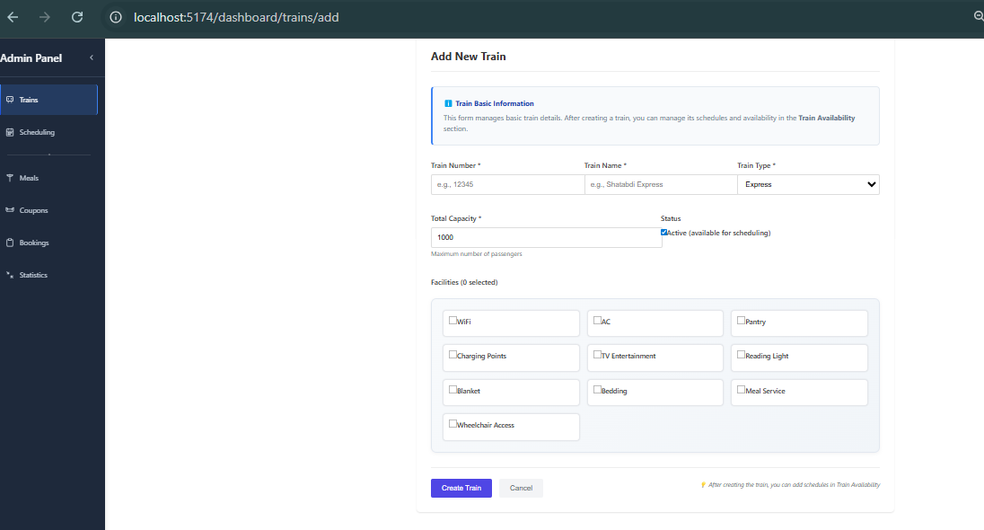

Booking Management- Admin Role
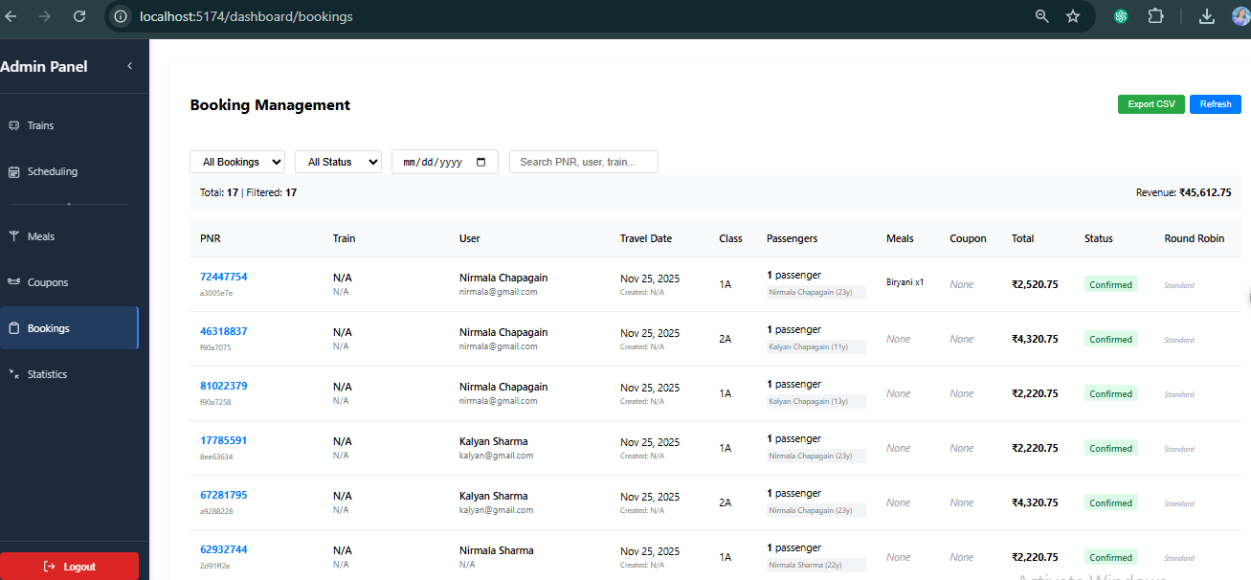

Manage Meals- Admin Role
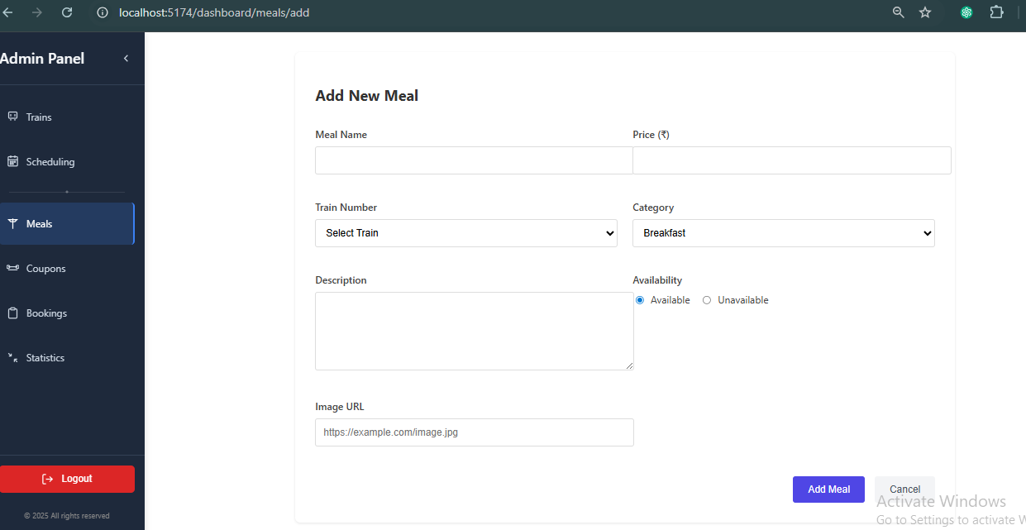

Manage Coupons- Admin Role
